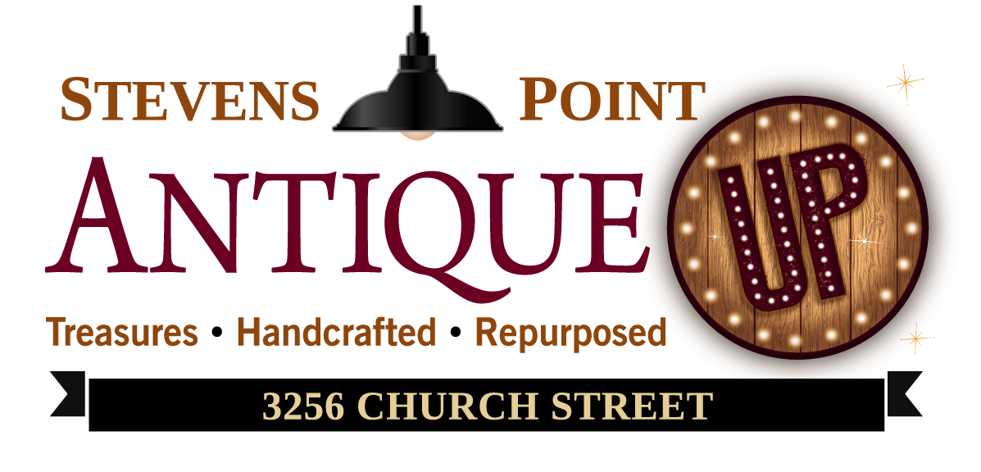
Antique Up Vendor Application

Applicant Information
Name:
Home Phone: |  | Cell Phone: | Email:
Current address:
City: |  | State: | ZIP Code:

Alternate Contact
Name
Phone: | E-mail: |  | Relationship:

Vendor Information
Category (please indicate 1st, 2nd & 3rd preference):
Antiques Vintage Mid-Century Modern Handcrafted Repurposed Shabby Chic Primitive
Merchandise (please circle all that apply):
Jewelry Hobby Home Décor Furniture Coins Lawn/Garden Art Tools Automotive Household Clothing Other:________________
Desired Start Date: __________________________
Would you like to be placed on a waiting list in the event there is no space available: YES NO
Desired size/type of booth (please indicate 1st, 2nd & 3rd preference):

Booths: 5x8 8x12 8x10 10x10 8x20 10x20 (booth prices vary on size and location)

Shelving Units: 6x1 ($55/month)

Display Cases: 3x4 ($50/month)

Chicken Wire Wall Space: 4x8 ($15/month) 8x8 ($30/month)

Regular Wall Space: Custom ($20-$40/month)

Wall & Floor Space: 2x8 ($45/month) 2x10 ($50/month) Custom Available ($40-$60/month)

Back Stock Storage: Staff will restock and refresh your booth daily ($30/month)

